Geometrie computational

# Curs 1 (24.02.2021)

Ecuatia dreptei.

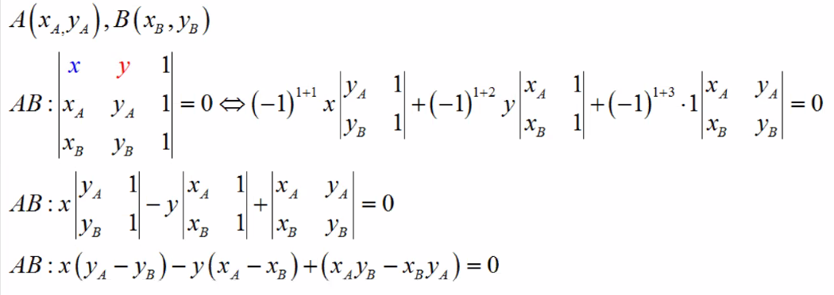

Distanta dintre doua puncte:

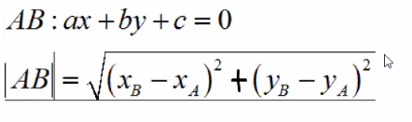

Conditia de coliniaritate:

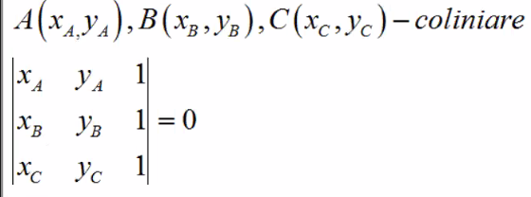

xA*yB + xB*yC + xC*yA – xC*yB – xB*yA – xA*yC = 0

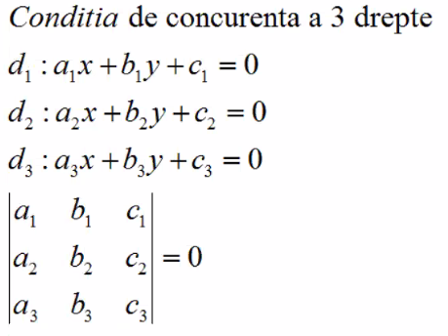

a1*b2*c3 + a2*b3*c1 + a3*b1*c2 - a3*b2*c1- a2*b1*c3 – a1*b3*c2=0